Subject: 🔥 May Technical Meeting: Combustible Dust – Science, Standards & Strategies
Dear Greater Boston ASSP Members,
We’re excited to invite you to our May 2025 Technical Meeting, where we’ll be tackling one of the most serious and often overlooked hazards in our industry: combustible dust. Whether you're an EHS leader, engineer, or safety professional, this is an event you won't want to miss.

🔥 Combustible Dust: Science, Standards & Mitigation Strategies
📅 Date: May 2025
🕠 Time: 4:00 PM – 7:00 PM
📍 Location: United Alliance Services Training Center, Canton, MA
🍽 Food provided | 🍸 Cash bar available courtesy of United Alliance Services

🎤 Featured Presenters:
Rich Sarnie, United Alliance Services
– Practical, field-tested strategies for mitigating combustible dust risks
– Lessons from real-world incidents and Dust Hazard Analysis best practices
Dr. Tim Myers, Principal Engineer, Exponent
– Scientific insights on combustible dust behavior in food, pharma, and metals
– Overview of OSHA’s Combustible Dust NEP, NFPA 660, and CCPS guidance

✅ Why Attend?
- Learn how to recognize and manage combustible dust hazards in your workplace
- Understand key regulations and how to apply them effectively
- Gain practical tools you can use immediately
- Enjoy food, networking, and real talk with industry experts
Attendees will receive 0.2 Continuing Education Units (CEUs) for participating in this event.

👉 [Register Here]
This event is open to all Greater Boston Chapter members, non-members, and their guests in the Greater Boston safety community — but space is limited, so be sure to reserve your seat early!
We look forward to seeing you there for great food, drinks, and an engaging discussion that could help prevent the next catastrophic explosion.
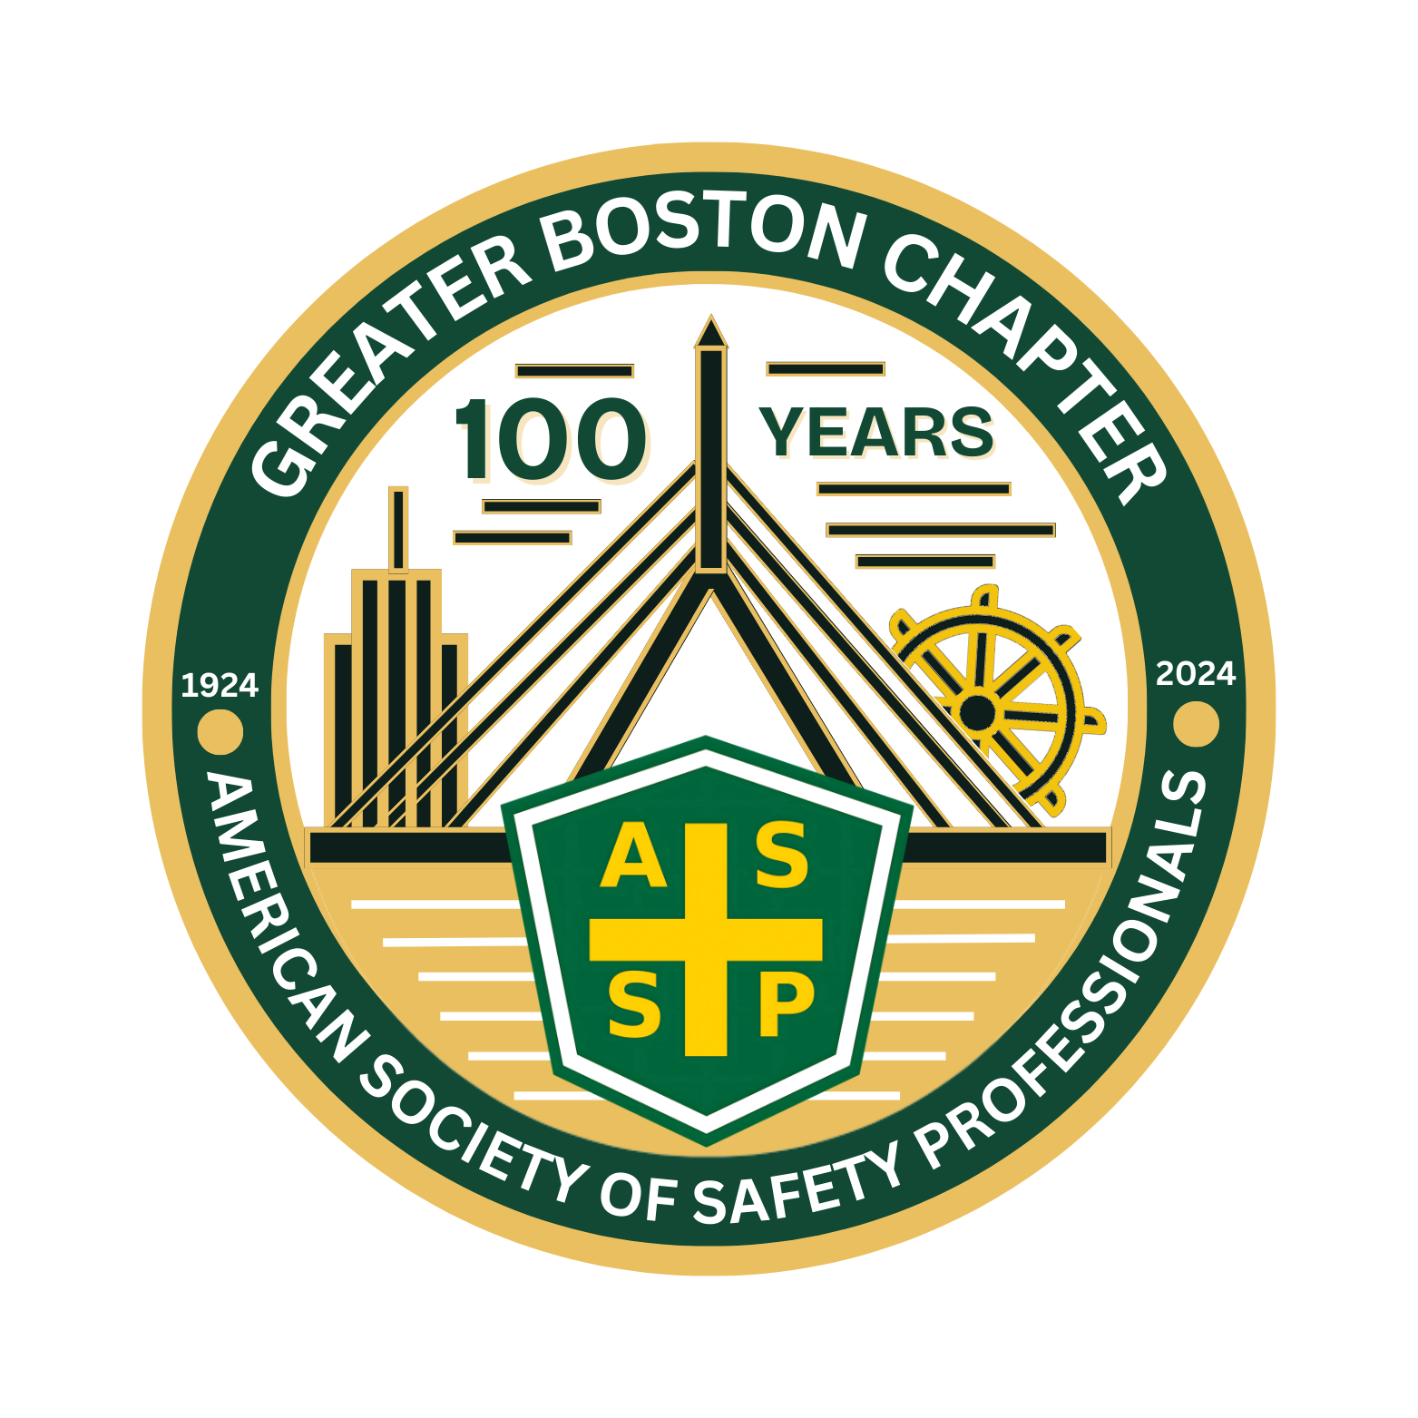

Best Regards & Be Safe,
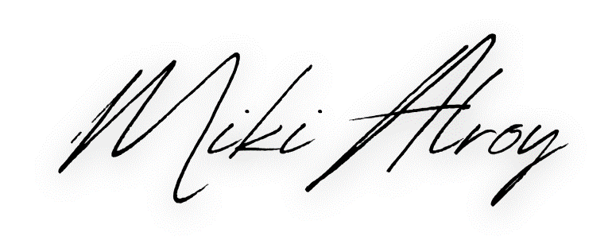
Michael “Miki” Alroy
President, Greater Boston Chapter
American Society of Safety Professionals
📧 info@greaterbostonassp.org
🌐 greaterboston.assp.org

